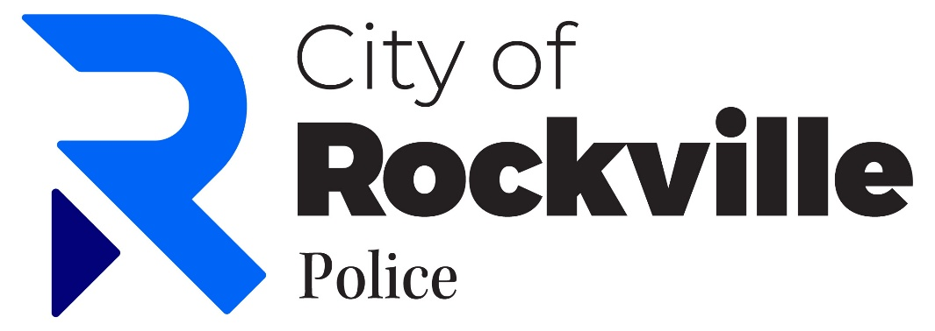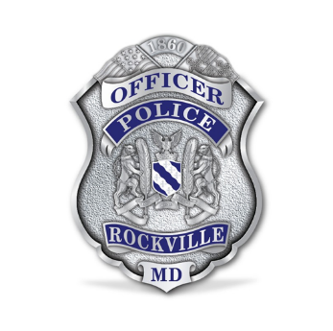

Community Policing Advisory Board

AGENDA for Thursday, June 4, 2025 (7:00pm to 8:30pm)
Rockville City Police Station 2 W. Montgomery Ave, Rockville, MD 20850

TIME | AGENDA ITEM | Process
7:00 – 7:10 | Convene Board  a. Welcome  b. Roll Call  c. Approve Last Meeting Minutes (VOTE)  d. Board Members coming & going | Commence
7:10 – 7:35 | Guest speakers (see below)  a. Members of the Public  b. Invited Guests | Speakers
7:35 – 8:05 | RCPD (Act. Bill Nieberding)  a. Report & Latest Updates  b. Meet RPD  c. Other | Report
8:05 – 8:30 | CPAB Business  a. Discuss Mayor/CC Report due Sept  b. New Business  c. Next meeting: September 3, 2026  e. Adjournment (VOTE) | Discuss & Review

IMPORTANT NOTES:
- Agenda item times are estimates only. Items may be considered at times other than those indicated.
- Parking is available at Garza Parking Garage adjacent to station – meeting attendees do not need to pay.
- There will be a 3-minute limit for Guest Speaker oral statements. Written statement may be submitted via e-mail to Ebony Parker, at eparker@rockvillemd.gov, please submit by COB two days prior to meeting

